Name:________________________
BLUES Artist Comparison
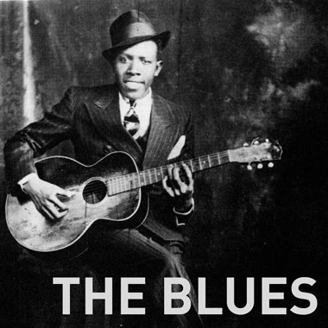
This chart should help you record some basic information about two blues artists as you complete your webquest. When you have completed your chart.
Name  Years Lived  (year-year) | What were some important events that occurred during their lifetime and in the U.S.? | Describe the music of your artist (lyrics, instrumentation, vocal style, form, etc.) | How did the artist’s musical style develop? | What have other musicians learned from them?

