Rikki-Tikki-Tavi PROJECT
Choose one of the projects to demonstrate your understanding of the characters and conflict in Rikki-Tikki-Tavi. (Conflict is two or more forces working against each other. Conflicts can be internal or external.)
There are 3 choices for this project, PICK 1 of the following:
Option 1: Visual Expression
For this option, you will create a poster. The poster may reflect a specific scene from the story or show a greater literal or abstract thematic conflict. The poster must be full-color and full poster board size, approx. 1.6’ x 2’ or larger. The quality of the art is not an issue, but effort is essential. The poster must be accompanied by a 2-paragraph write up. The first paragraph will describe the conflict that is portrayed in the poster. The second paragraph must explain your artistic process. By this I mean, why you chose the conflict you did and why you chose to portray it that way (explain design, image, color choice, etc.)
Keys for success: THINK about what you want to do, why you want to do it, and how you want to do it. Plan your poster on paper before you make it. Fill the space on the poster, and don’t leave empty space. Be sure to use MLA style on the written component (font, spacing, heading, margins, etc.)
Option 2: Perspective Writing Task
For this option, you will retell part of the story of Rikki-Tikki-Tavi from one of the character’s point of view. (The story is written in 3rd person omniscient, which means the narrator is all knowing and outside of the story). You will choose a scene of conflict to rewrite. You will not paraphrase or summarize. You will tell what happened in the voice of one of the main characters. This is not an essay, so it does not need to follow standard 5-paragraph organization. It needs to be a minimum of 2 pages long. It should be coherent and cohesive. It must be in MLA format. You will do a rough draft (can be hand written) and edit it or have it edited. You will need to turn in the draft with the final typed copy. Keys for success: THINK it through before you start writing. Pretend to be the character whose point of view you are taking. Organize ideas with an outline or graphic organizer. Put a lot of effort into your rough draft. Be sure to use MLA style (font, spacing, heading, margins, etc.).

Option 3: R.A.F.T Assignment
For this R.A.F.T. assignment, you will become one of the characters from Rikki-Tikki-Tavi.
Role | You are taking the ROLE of any of the animals that live in the garden around the bungalow. You may not take the ROLE of one of the humans.
Audience | Your AUDIENCE is all of the animals and humans that live at the bungalow.
Format | The FORMAT of this project is a “WANTED” poster that can be posted around the bungalow/garden.
Topic | Your TOPIC is to show that your enemy is a danger to the rest of the animals and humans at the bungalow. You must prove that your enemy should be hunted down and captured, DEAD OR ALIVE.
Your poster must include:
- Must be full-color and full poster board size, approx. 1.6’ x 2’ or larger.
- A picture of the wanted character (20 points)
- The name of the wanted character (10 points)
- A physical description (height, weight, color, identifying marks, etc.) of the wanted character – must use at least 3 descriptive adjectives to describe character (30 points)
- Why the character is wanted and why he/she is a danger to the other characters – must be 1 paragraph long and include at least 3 specific details from the story (30 points)
- Where the character was last seen and the reward for the character’s capture – must be 1 paragraph long and include specific details (10 points)

For this R.A.F.T. assignment, you will become one of the characters from Rikki-Tikki-Tavi.
Role | You are taking the ROLE of any of the animals that live in the garden around the bungalow. You may not take the ROLE of one of the humans.
Audience | Your AUDIENCE is all of the animals and humans that live at the bungalow.
Format | The FORMAT of this project is a “WANTED” poster that can be posted around the bungalow/garden.
Topic | Your TOPIC is to show that your enemy is a danger to the rest of the animals and humans at the bungalow. You must prove that your enemy should be hunted down and captured, DEAD OR ALIVE.
Your poster must include:
- A picture of the wanted character (20 points)
- The name of the wanted character (10 points)
- A physical description (height, weight, color, identifying marks, etc.) of the character – must use 5 descriptive adjectives (30 points)
- Why the character is wanted and why he/she is a threat to the other characters – must include at least 5 facts from the story (30 points)
- Where the character was last seen and the reward for information leading to the character’s capture (10 points)

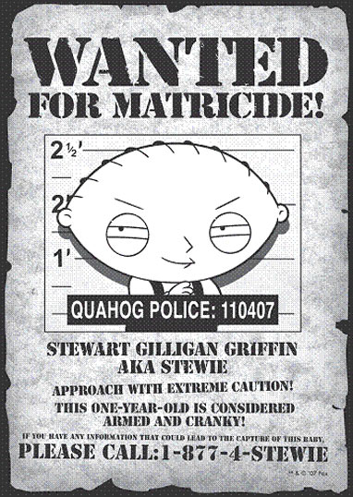
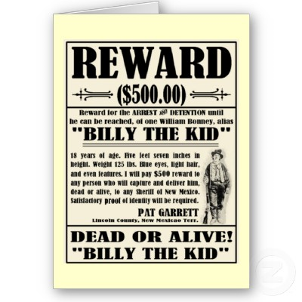
Here are two examples of WANTED posters:

